Logbook 1
Name: | Guru
Week Date: | Part A -Meeting 1 of 8
(The above information is for you to keep track of which week this log is applicable for. This information is not required in the online logbook as the system will find your name, your supervisor’s name, and take the submission date, automatically. You must submit the online log in the relevant week. Logs cannot be backdated to missed weeks.)

Meeting date:  (please note if no meeting is planned this week) | Date and day:  28 May 2026 (Thursday)
Work Undertaken this week:  (No more than 4000 characters, including spaces) | From the project title that you have selected, do a research on similar projects ( at least 4) and summarize your finding on each one.  1. Tesla Optimus  Tesla Optimus is a general-purpose humanoid robot designed to perform repetitive and hazardous tasks. It utilizes artificial intelligence, computer vision, and advanced motion control systems to interact with its environment. The robot can identify objects, navigate spaces, and perform basic pick-and-place operations. The project demonstrates how AI can be integrated with humanoid robotics to automate real-world tasks.  2. SoftBank Pepper Robot  Pepper is a social humanoid robot capable of understanding speech, recognizing human emotions, and interacting naturally with users. It uses speech recognition and cloud-based AI services to process voice commands. The project highlights effective human-robot interaction through voice communication and intelligent responses.  3. UBTECH Walker Humanoid Robot  Walker is a humanoid robot developed for home and service applications. It incorporates voice control, autonomous navigation, object detection, and robotic arm manipulation. The robot can respond to user commands and perform simple pick-and-place tasks. This project demonstrates the integration of perception, mobility, and manipulation within a single humanoid platform.  4. NAO Humanoid Robot  NAO is a programmable humanoid robot widely used in research and education. It supports speech recognition, object recognition, and gesture-based interactions. The robot can execute commands provided by users and perform autonomous movements. The project provides valuable insights into AI-assisted robotic control systems and human-robot communication.  Summary of Findings  The reviewed projects show that successful humanoid robots combine voice recognition, artificial intelligence, object detection, motion control, and manipulation systems. Most systems use microphones for speech input, cameras for environmental perception, and robotic arms for object handling. These findings will be applied in developing the proposed AI-powered humanoid robot capable of responding to voice commands and performing pick-and-place operations.
Problems encountered:  (No more than 4000 characters, including spaces) | What is the information that are not clear or sufficient for your intended project. If no, you can skip this.  Nil:
Tasks agreed for upcoming week:  (No more than 4000 characters, including spaces) | What are your plan actions/task until the next progress meeting.  Plan Actions / Tasks Until Next Progress Meeting:  - Conduct further research on humanoid robot architectures, AI integration, and robotic manipulation systems.  - Finalize the overall system requirements and functional specifications of the robot.  - Develop a detailed system block diagram showing the interaction between hardware and software components.  - Select suitable hardware components, including the microcontroller, camera module, microphone, servo motors, and gripper mechanism.  - Design the initial mechanical structure of the humanoid robot using CAD software.  - Investigate and compare speech recognition and object detection algorithms for implementation.  - Develop a preliminary software architecture for voice command processing and robot control.  - Prepare the initial concept sketch and system design documentation for supervisor review.  - Identify potential technical challenges and propose mitigation strategies.  - Create a project timeline and work breakdown structure for the development phase.
Figures:  (Upload image files in the online Log Form, but feel free to keep notes here about which images you intend to upload. Use “Figure Caption” information as the filenames, e.g., “Figure 1 – A screenshot of the initial constrained Sketch in CATIA.jpg”) | - Provide / Sketch an artistic view of your project. A rough one will do. You can use any software like PPT to design this sketch:  Figure 1 illustrates the conceptual design of the proposed AI-powered humanoid service robot. The robot is equipped with a camera-based vision system, voice recognition module, AI processing unit, and robotic arm with gripper mechanisms. The system is designed to interact with users through voice commands, identify objects within its environment, and perform pick-and-place operations autonomously. The robot can be deployed in educational institutions, offices, laboratories, and service environments to assist users in routine tasks.  Updated Objectives  Objective 1  To design and develop a humanoid robot capable of interacting with users through AI-based voice recognition and command processing.  Objective 2  To implement a computer vision system for object detection, recognition, and localization using a camera sensor.  Objective 3  To develop a robotic manipulation system that enables the robot to autonomously grasp, transport, and place objects based on user instructions.  - Update Block diagram of your system:  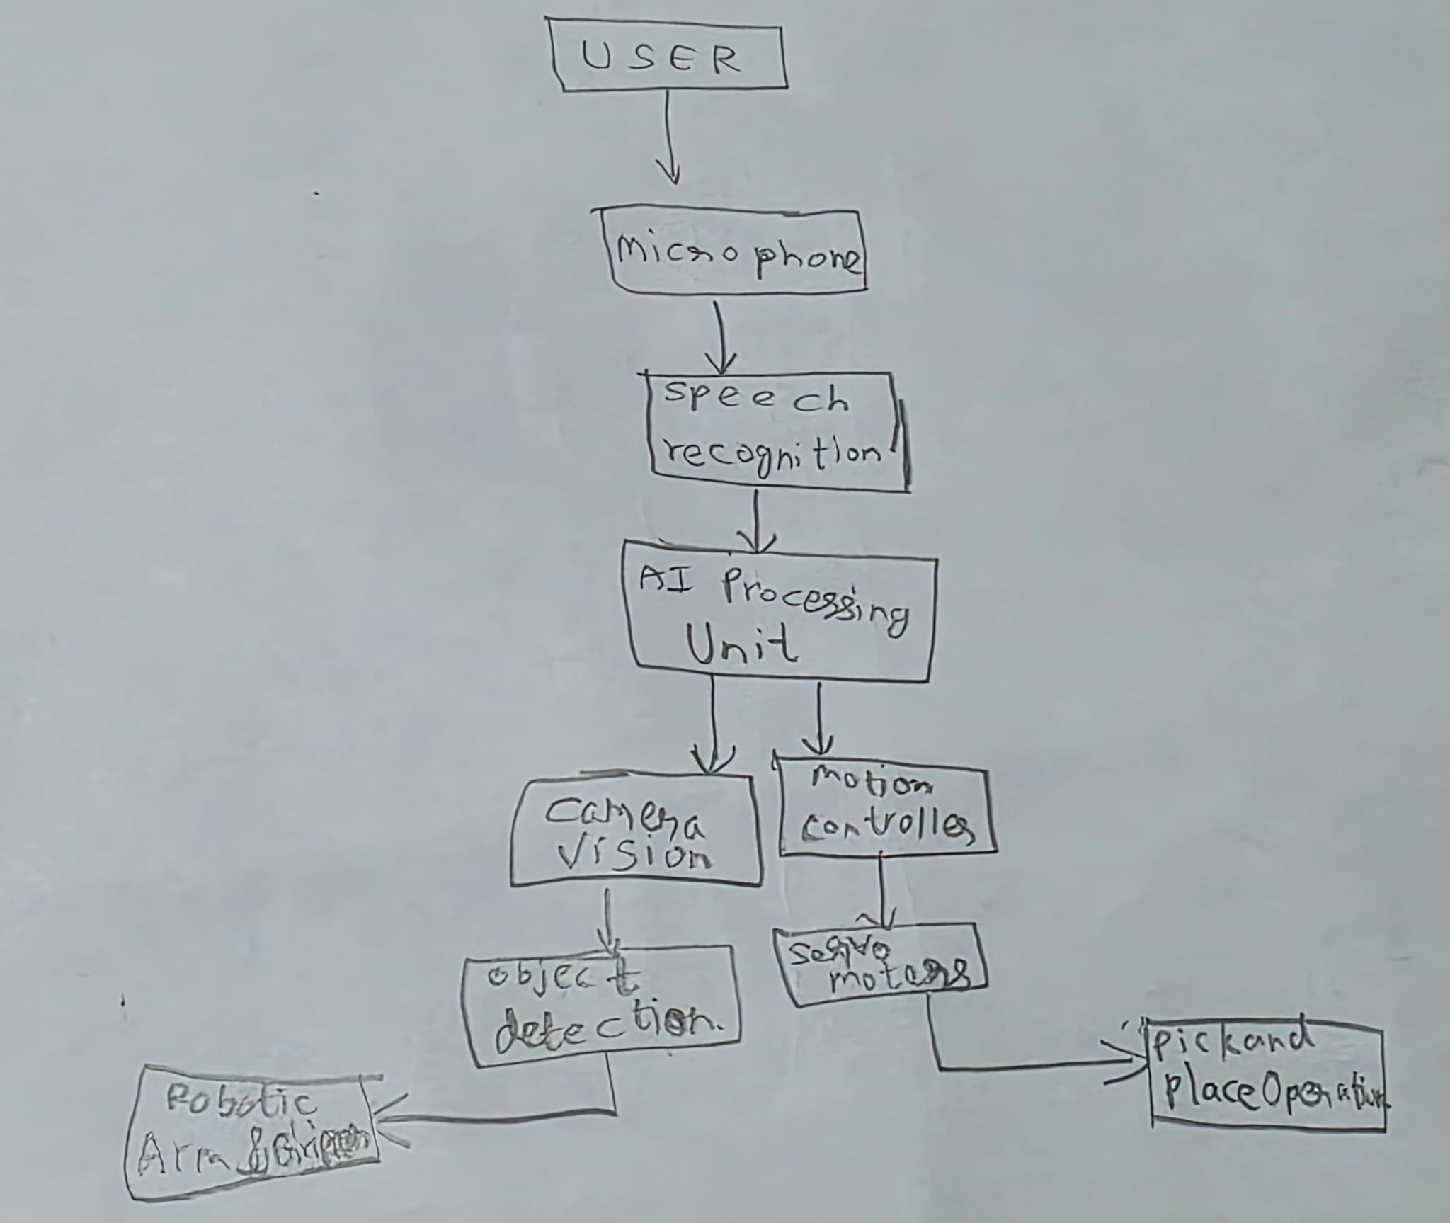  - Key software codes/modules that need to be developed  Speech recognition and voice interaction.  Emotion and face recognition.  Human-robot communication.  Autonomous navigation.  Customer assistance applications.  - Any Quality and Regulatory issued to be addressed?  Quality issues:  Voice Recognition Accuracy  - The robot should accurately recognize and respond to voice commands under different noise conditions.  Object Detection Reliability  - The camera and AI vision system must correctly identify and locate objects under varying lighting conditions.  Pick-and-Place Precision  - The robotic arm and gripper should grasp and place objects accurately without dropping or damaging them.  System Reliability  - The robot should operate continuously without software crashes or communication failures.  Response Time  - The system should process commands and execute actions with minimal delay.  - Battery and Power Management  Safety and Regulatory Issues  - Human Safety  - Moving parts such as robotic arms and joints must not pose injury risks to users.  - Emergency Stop Function  - An emergency stop mechanism should be included to immediately halt all robot movements during unsafe situations.  - Electrical Safety  - All electrical components and wiring must comply with laboratory and institutional safety requirements.  - Collision Avoidance  - The robot should detect obstacles and avoid collisions with people and surrounding objects.  - Data Privacy  - Voice recordings and user interaction data should be handled securely and used only for intended purposes.  - Compliance with Institutional Guidelines  - The project should comply with university laboratory regulations and ethical guidelines for AI and robotics development.

